**Hoplonemertea sp. C SCAMIT** SCAMIT Vol. , No

Group: Nemertea: Enopla: Hoplonemertea

Date Examined: 16 August 2011

Voucher By: Tony Phillips

SYNONYMY: Hoplonemertea sp HYP2 Phillips 2007

Amphiporidae sp HYP 2 Phillips 2007

Amphiporus sp C of Hyperion Phillips 1999

LITERATURE:

Bernhardt, P. 1979. A key to the Nemertea from the intertidal zone of the coast of California. (Unpublished).

Coe, W.R. 1901. Papers from the Harriman Expedition, 20, the Nemerteans. Proc. Wash. Acad. Sci., 3:1-110.

Coe, W.R. 1905. Nemerteans of the west and north-west coasts of North America. Bull. Mus. Comp. Zool. Harvard Coll. 47:1-319.

Coe, W.R. 1940. Revision of the nemertean fauna of the Pacific Coast of North, Central and northern South America. Allen Hancock Pacific Exped. 2(13):247-323.

DIAGNOSTIC CHARACTERS:

1. Body white, thick, generally of uniform width, intestinal diverticula darkly pigmented.
2. Head region, anterior to cephalic groove, narrower than remainder of body; posterior end rounded, same width as middle region of body (Figure 1).
3. Dorsal ridge running almost full length of body, ¼ or slightly greater the width of body (Figure 2).
4. Proboscis sheath extends almost full length of body.
5. Stylet slightly < 2x to almost 3x length of basis (s/b ratio 1.67 – 2.77), basis rounded (bulb shaped) 2 pouches of accessory stylets (3-5/pouch).

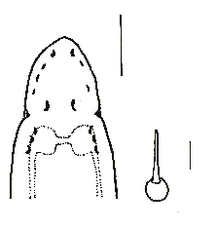

1. Eyes not visible uncleared; cleared specimens with single row 3 eyes along each side of anterior edge of head (anterior pair crescent shaped), single pair of crescent shaped eyes in front of brain lobes, with 2-3 crescent shaped eyes along side of brain lobes.
2. Specimens observed 4 - 47 mm (47 mm incomplete).

RELATED SPECIES AND CHARACTER DIFFERENCES:

The external morphological character of an elevated dorsal ridge extending longitudinally almost the full length of the body and the cleared eye pattern is distinctive to this provisional species. This is the only enoplan observed from the SCB with the raised dorsal ridge extending longitudinally along the body. The cleared eye pattern has not been seen in any other enoplans found in the southern California Bight. The shape of the basis is not unique to this provisional species. It has also been observed in Nipponemertes punctatula and Hoplonemertea sp SD3. The s/b ratio is similar for all three species, but eye patterns and external morphology differentiate H. sp C SCAMIT from the other two species.

DEPTH RANGE: 10 - 15 meters

DISTRIBUTION: Santa Monica Bay, Marina del Rey; fine to medium sands

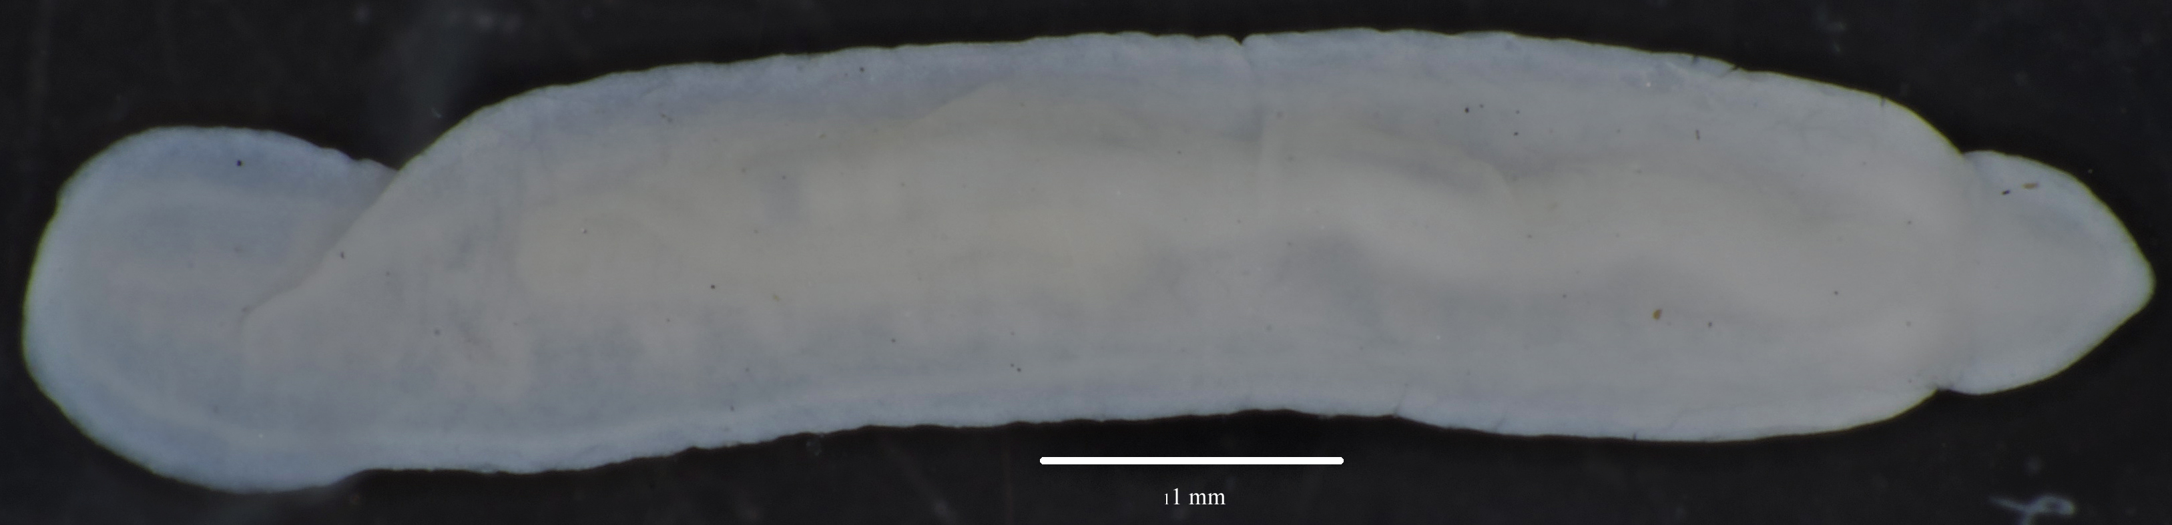

Figure 1. Hoplonemertea sp C SCAMIT. Santa Monica Bay, A2, 16 m, 28 September 2006.

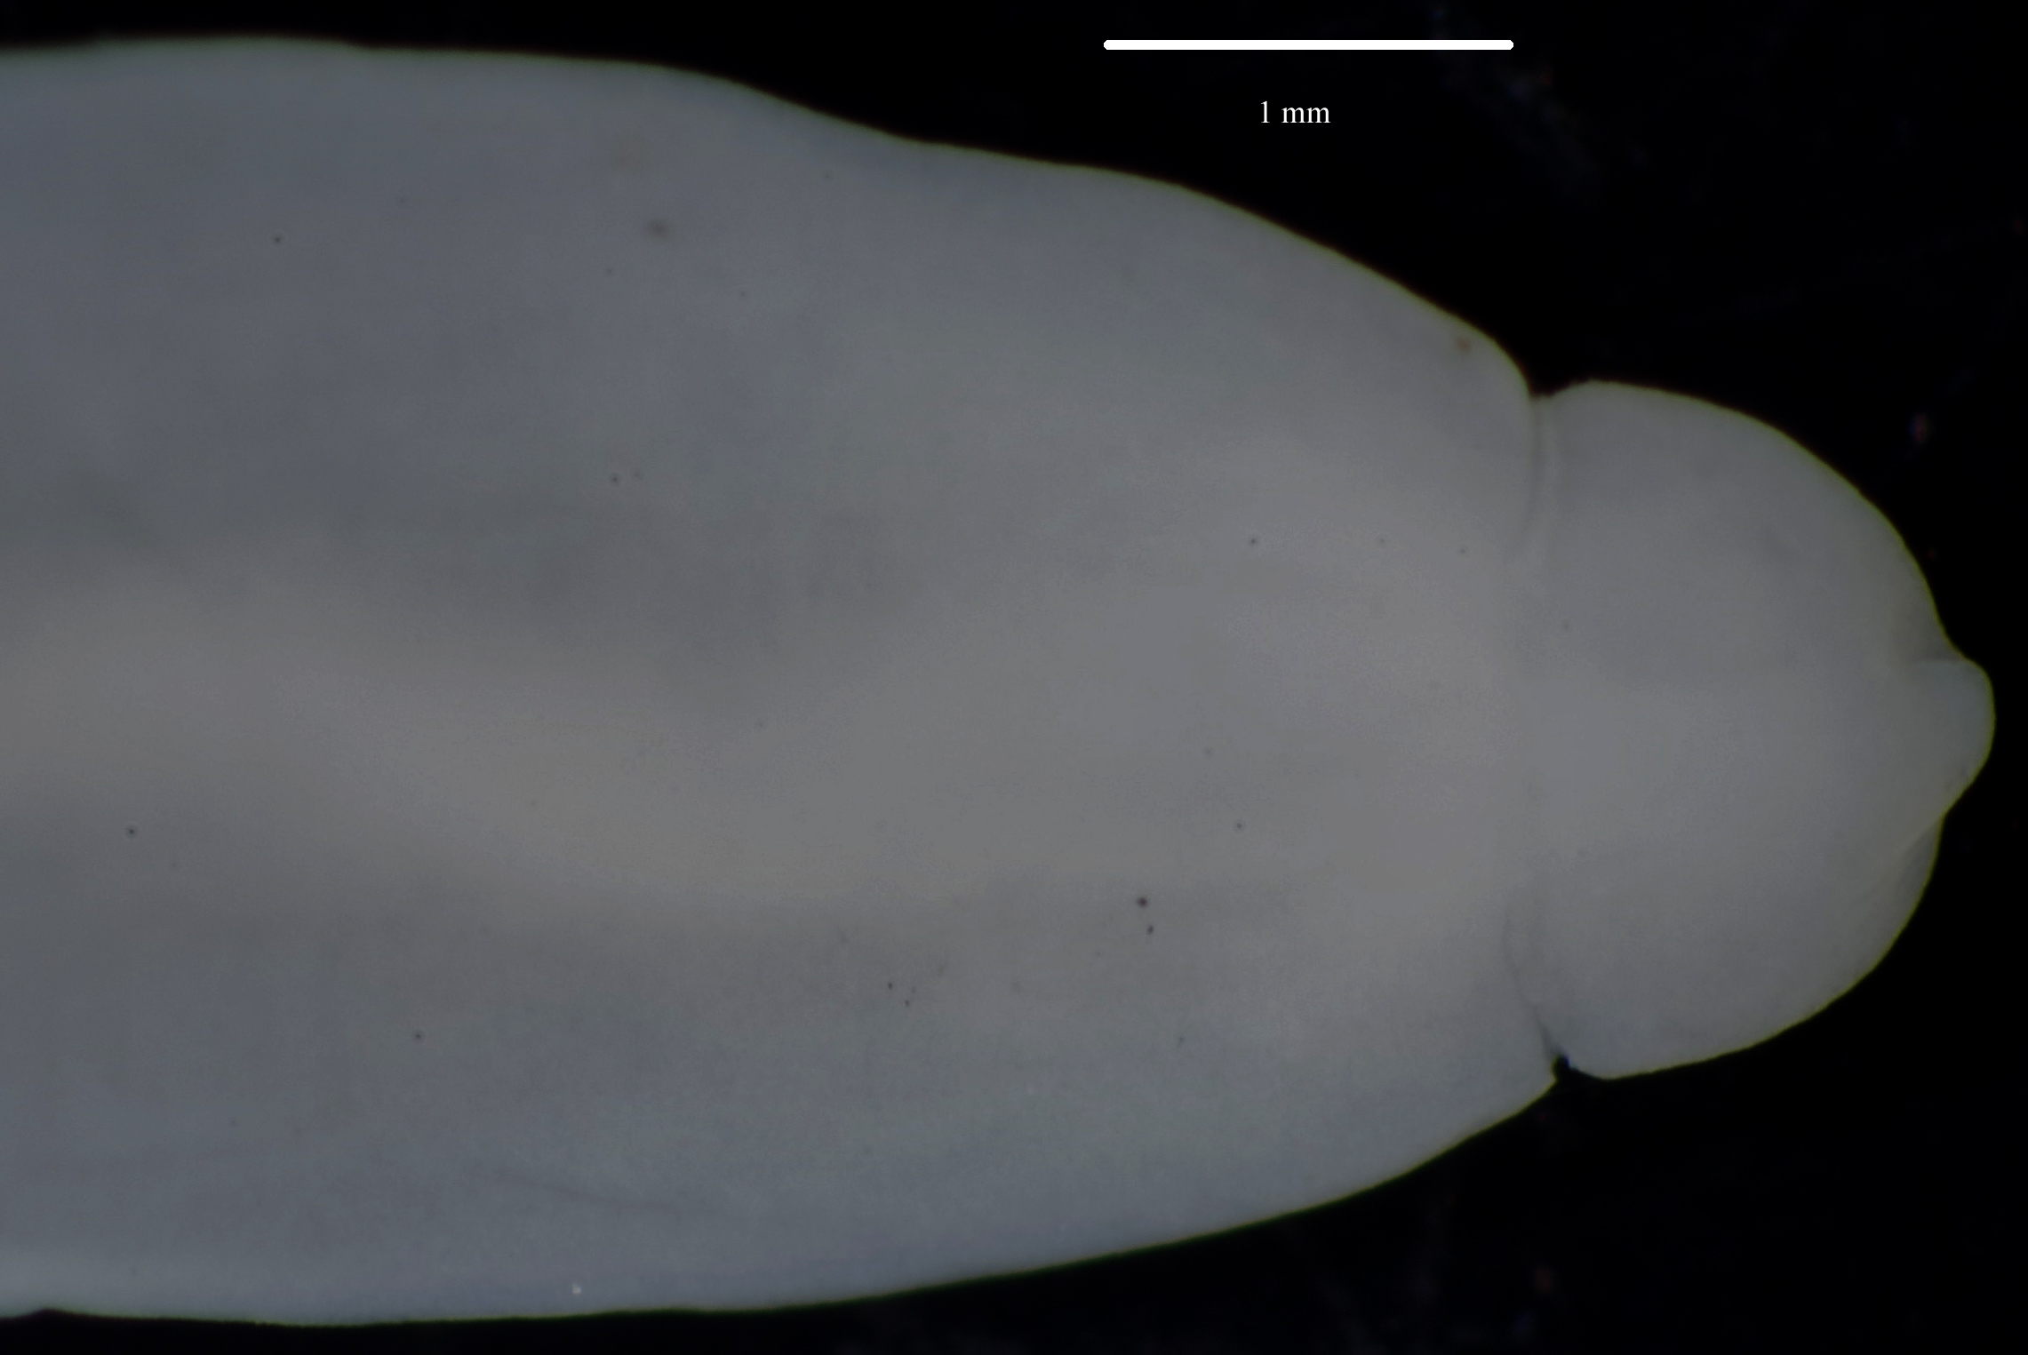

Figure 2. Hoplonemertea sp C SCAMIT. Anterior end showing dorsal ridge.