**Hoplonemertea sp. B SCAMIT** SCAMIT Vol. , No

Group: Nemertea: Enopla: Hoplonemertea

Date Examined: 16 August 2011

Voucher By: Tony Phillips

SYNONYMY: Hoplonemertea sp HYP1 Phillips 2007

Amphiporidae sp HYP 1 Phillips 2007

Amphiporus sp B Phillips 1988

LITERATURE:

Bernhardt, P. 1979. A key to the Nemertea from the intertidal zone of the coast of California. (Unpublished).

Coe, W.R. 1901. Papers from the Harriman Expedition, 20, the Nemerteans. Proc. Wash. Acad. Sci., 3:1-110.

Coe, W.R. 1905. Nemerteans of the west and north-west coasts of North America. Bull. Mus. Comp. Zool. Harvard Coll. 47:1-319.

Coe, W.R. 1940. Revision of the nemertean fauna of the Pacific Coast of North, Central and northern South America. Allen Hancock Pacific Exped. 2(13):247-323.

DIAGNOSTIC CHARACTERS:

1. Body white, thick, generally of uniform width, head narrower with slightly pointed anterior end, posterior end pointed.
2. Proboscis sheath extends almost full length of body; proboscis papillated.
3. Basis 1.25- 2.5X length of stylet (s/b ratio 0.39 – 0.71) for specimens 5 – 9 mm; basis truncate and tubular, one accessory pouch observed with 1-2 accessory stylets.

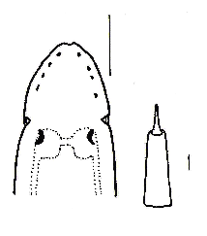

1. Eyes not visible uncleared; cleared specimens with single row of 4-5 round eyes along each side of anterior-lateral edge of head, single pair of large crescent eyes on each side of brain lobes, just posterior to cephalic groove.

RELATED SPECIES AND CHARACTER DIFFERENCES:

The distinct, cleared eye pattern observed has not been seen in any other enoplan found in the southern California Bight.

DEPTH RANGE: 5-30 meters

DISTRIBUTION: San Diego to Goleta

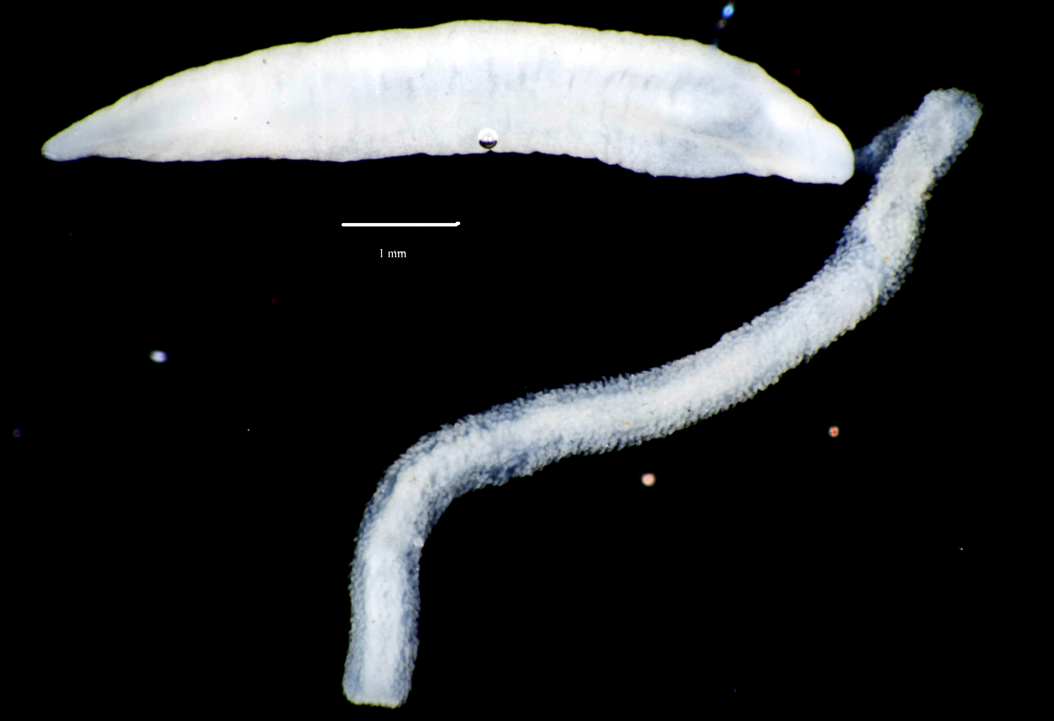

Figure 1. Hoplonemertea sp B SCAMIT. Santa Monica Bay, A2, 16 m, 28 September 2006.