Tetrastemma reticulatum Coe 1904 SCAMIT Vol. , No
Group: Nemertea: Enopla: Hoplonemertea: Tetrastemmatidae

Date Examined: 27 July 2011
Voucher By: Tony Phillips

SYNONYMY: None

LITERATURE:
Bernhardt, P. 1979. A key to the Nemertea from the intertidal zone of the coast of California. (Unpublished).
Coe, W.R. 1904. The Nemerteans. Harriman Alaska Expedition 11:1-220.
Coe, W.R. 1905. Nemerteans of the west and north-west coasts of North America. Bull. Mus. Comp. Zool. Harvard Coll. 47:1-319.
Coe, W.R. 1940. Revision of the nemertean fauna of the Pacific Coast of North, Central and northern South America. Allen Hancock Pacific Exped. 2(13):247-323.
Coe, W.R. 1944. Geographical distribution of the nemerteans of the Pacific coast of North America, with descriptions of two new species. Journal of the Washington Academy of Sciences, 34(1):27-32.
Correa, D.D. 1964. Nemerteans from California and Oregon. Proc. Calif. Acad. Sci., 31(19):515-558.
Crandall, F.B. & J.L. Norenborg. 2001. Checklist of the Nemertean Fauna of the United States. Nemertes (http://nemertes.si.edu). Smithsonian Institution, Washington, D.D. pp. 1-36.

DIAGNOSTIC CHARACTERS:
- The head is crème to white, with reddish-brown pigmentation that can be triangular to rectangular (edges tend to fade out), anterior to cephalic groove, variation in the size and shape occurred; the anterior end is rounded to quadrate; the body has elongated white ovals (variable in width) running between both sides of the body, with a narrow white stripe running longitudinally down the body (Figure 1).
- Proboscis sheath extends almost full length of body, difficult to see due to body being pigmented, proboscis papillated.
- Basis approximately equal to one-half of stylet (s/b ratio 0.55) (only two specimens observed), basis cylindrical shape, narrower near stylet and base slightly rounded, bottom half of basis mottled gray-black to black, 1-2 accessory pouches (1 – 2 stylets).
- Eyes not visible uncleared; cleared specimens with single pair of round eyes near anterior edge of pigment patch on head, second pair of round eyes just posterior to cephalic furrow.

RELATED SPECIES AND CHARACTER DIFFERENCES:
Only Tetrastemma nigrifrons and Oerstedia dorsalis complex could be confused for T. reticulatum. See discussion on related species and character differences for T. nigrifrons and Oerstedia dorsalis complex. See below for comparison of T. reticulatum and Oerstedia dorsalis complex.

DEPTH RANGE: Intertidal to 60 meters

DISTRIBUTION: San Diego to Goleta

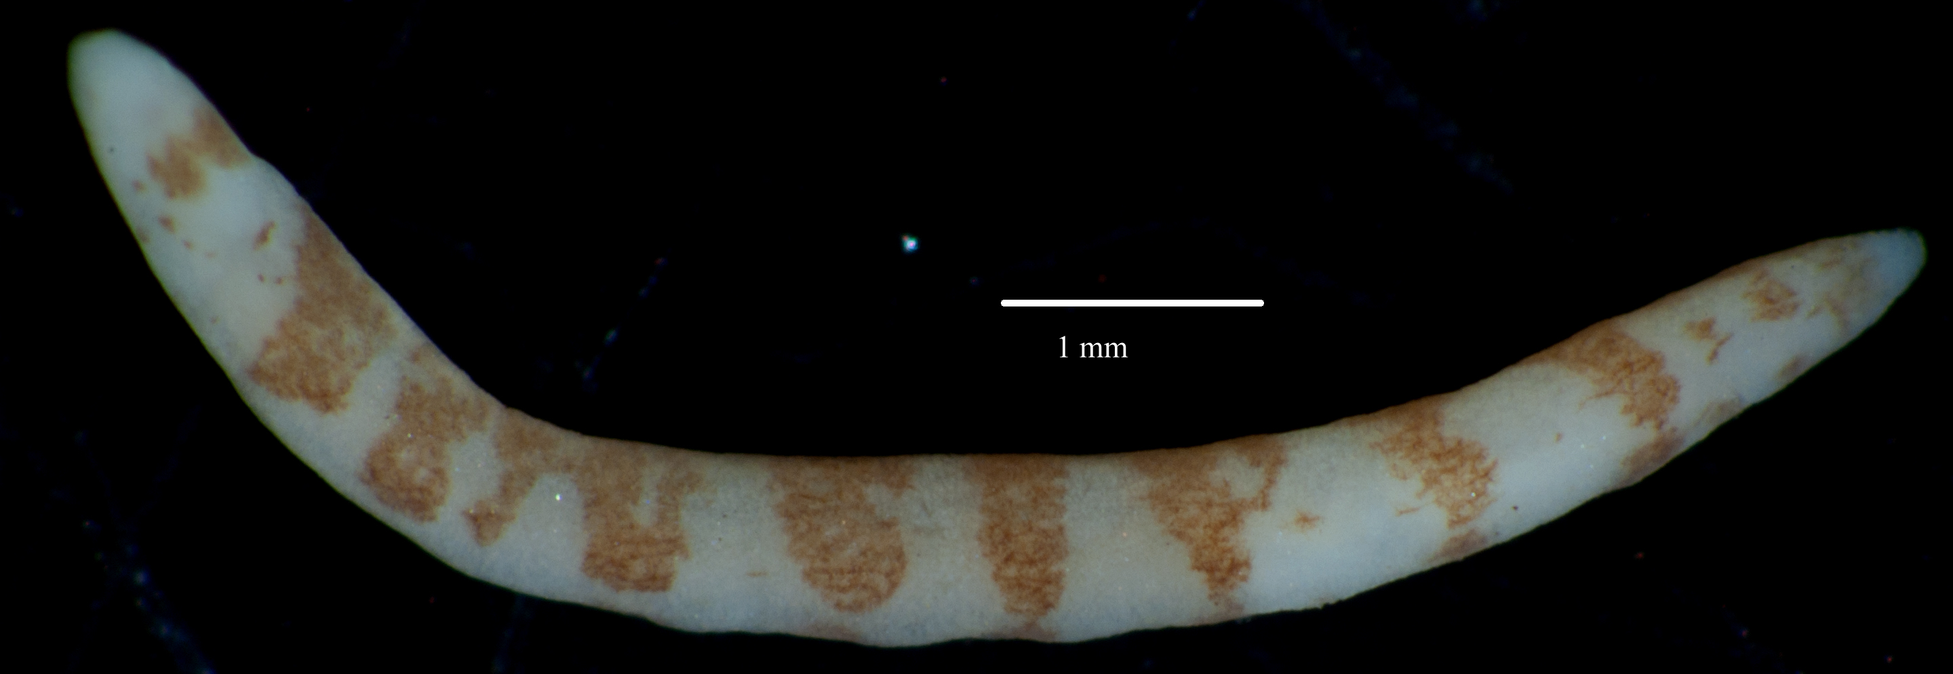

Oerstedia dorsal complex

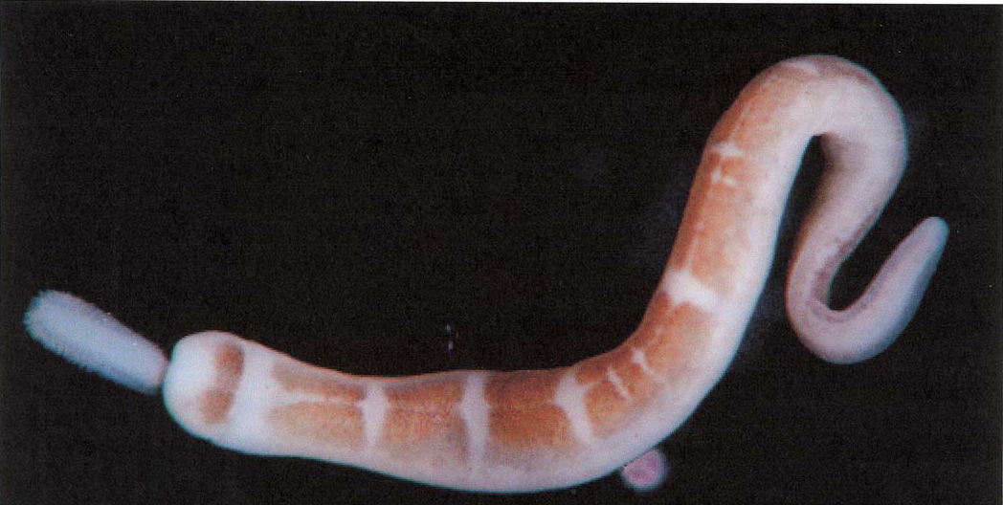

Tetrastemma reticulatum. Photo by Megan Lilly (12/05). San Diego, Station I-23, 20 meters

