Tetrastemma nigrifrons Coe 1904 SCAMIT Vol. , No
Group: Nemertea: Enopla: Hoplonemertea: Tetrastemmatidae

Date Examined: 12 July 2011
Voucher By: Tony Phillips

SYNONYMY: None

LITERATURE:
Bernhardt, P. 1979. A key to the Nemertea from the intertidal zone of the coast of California. (Unpublished).
Coe, W.R. 1904. The Nemerteans. Harriman Alaska Expedition 11:1-220.
Coe, W.R. 1905. Nemerteans of the west and north-west coasts of North America. Bull. Mus. Comp. Zool. Harvard Coll. 47:1-319.
Coe, W.R. 1940. Revision of the nemertean fauna of the Pacific Coast of North, Central and northern South America. Allen Hancock Pacific Exped. 2(13):247-323.
Coe, W.R. 1944. Geographical distribution of the nemerteans of the Pacific coast of North America, with descriptions of two new species. Journal of the Washington Academy of Sciences, 34(1):27-32.
Correa, D.D. 1964. Nemerteans from California and Oregon. Proc. Calif. Acad. Sci., 31(19):515-558.
Crandall, F.B. & J.L. Norenborg. 2001. Checklist of the Nemertean Fauna of the United States. Nemertes (http://nemertes.si.edu). Smithsonian Institution, Washington, D.D. pp. 1-36.

DIAGNOSTIC CHARACTERS:
- The head is crème to white, with reddish-brown pigmentation that can be triangular to rectangular, anterior to cephalic groove, variation in the size and shape occurred; the anterior end is rounded to quadrate; the body has several variations from reddish-brown to reddish-purple pigmentation over the whole body, to one to three white bands running longitudinally down the body, to thin ovals centrally located on the dorsum running the length of the body. Another pigment variety which I am including within the T. nigrifrons variation is a specimen with the pigment patch on the head, but the body pigmentation is reversed, with a white body and a brownish-red pigment stripe running longitudinally down the center of the body.
- Proboscis sheath extends almost full length of body, difficult to see due to body being pigmented, proboscis papillated.
- Basis approximately equal to one-half to two-thirds length of stylet (s/b ratio0 .52 – 0.68), basis cylindrical with round to slight pear shape, narrower near stylet and base slightly rounded, lower one-third grayish-black coloration; 1-2 accessory pouches (1 – 2 stylets).
- Eyes not visible uncleared; cleared specimens with single pair of round eyes near anterior edge of pigment patch on head, second pair of round eyes just posterior to cephalic furrow.
- Size of specimens observed 2 – 11 mm.

RELATED SPECIES AND CHARACTER DIFFERENCES:
The pigment patch on the head of this species in combination with the many varieties of body pigmentation make the identification of Tetrastemma nigrifrons usually very easy. However, there is one species of Tetrastemma that could be confused with it. T. reticulatum Coe 1904 also has a reddish-brown pigment patch on the posterior portion of the head, overlying a crème- white base color. However, the body pigmentation is very distinctive. You could say that it is a combination of Oerstedia dorsalis and T. nigrifrons (variant zonatum Coe 1940) whose body pigmentation has centrally located thin ovals running the length of the body. T. reticulatum has white bands connecting both lateral sides that are found along the length of the body and a thin white stripe running longitudinally down the body (see T. reticulatum sheet). Coe (1940) actually named several of the various T. nigrifrons pigmentation patterns as variants. Figure 1 shows the different variations in pigment pattern that I have observed in my collections from the SCB. Variations A, B, and D would be labeled pallidulum, bicolor, and zonatum respectfully from Coe, 1940. Variations C and E were not drawn in Coe, 1940. Manchenko and Kulikova (1996) found that after doing enzyme analysis of five of these variants that they could not be separated as distinct species.

DEPTH RANGE: Intertidal to 20 meters

DISTRIBUTION: Puget Sound to Costa Rica

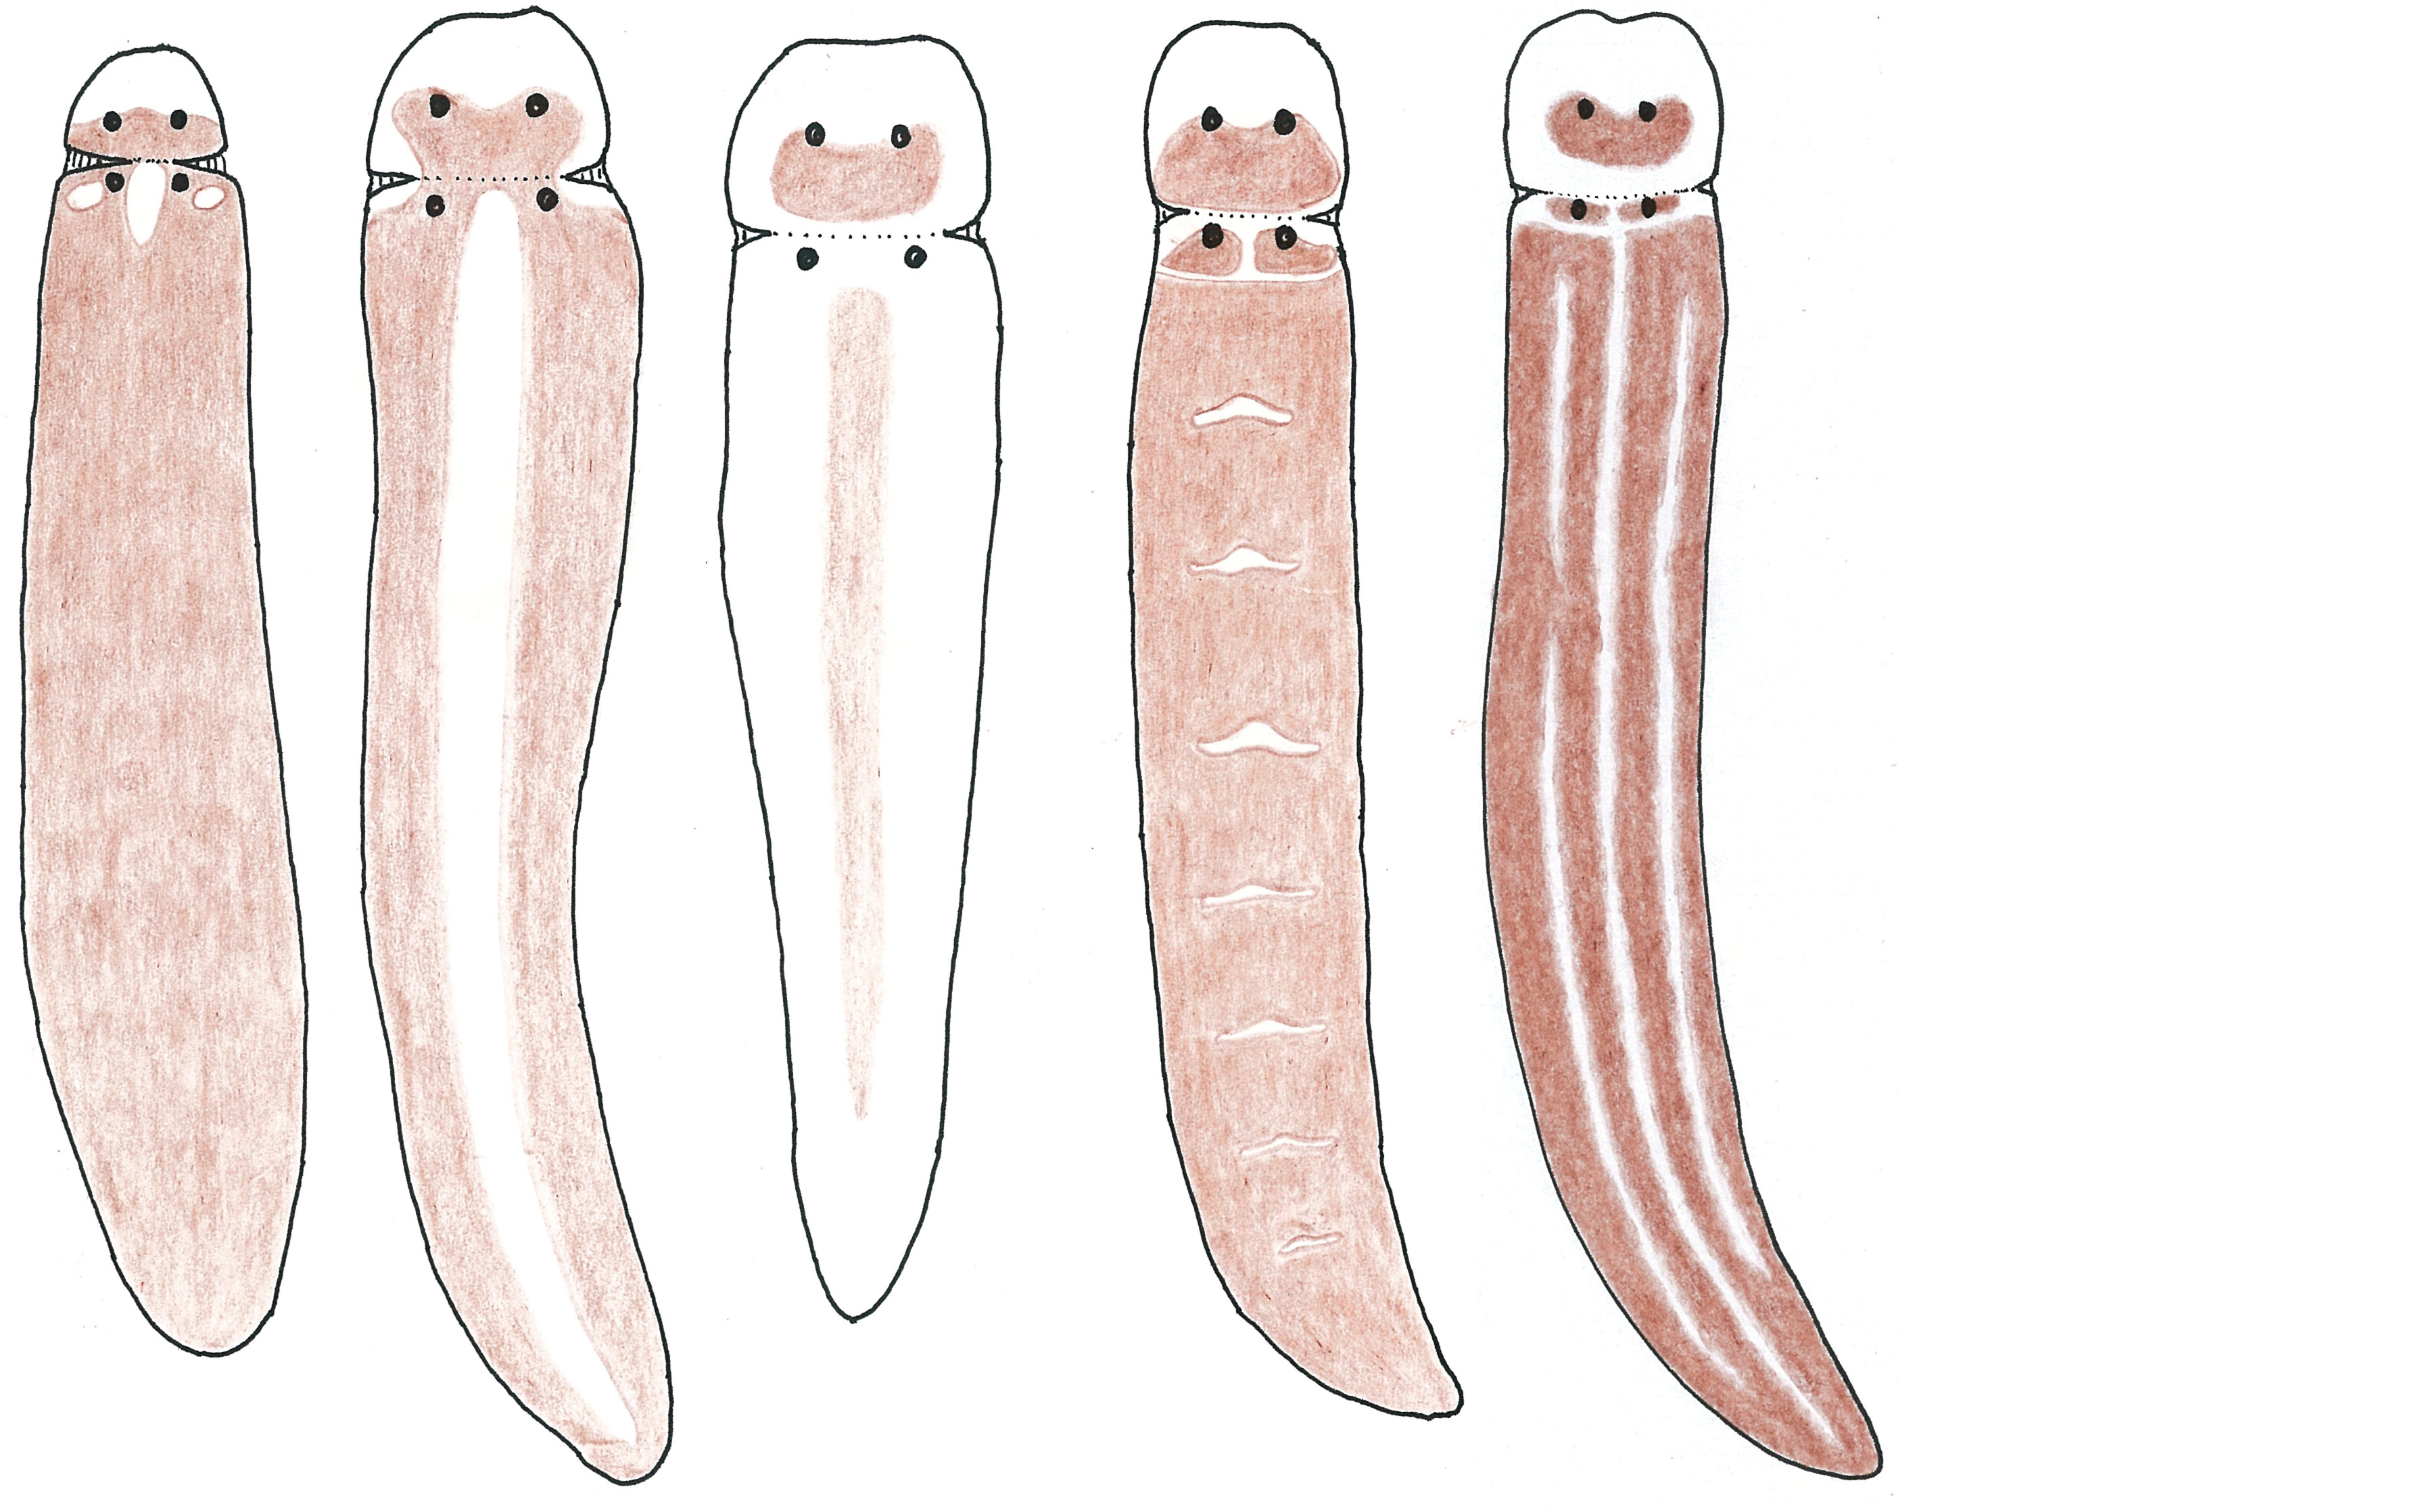

Var. A Var. B Var. C Var. D Var. E

Figure 1. Different forms of Tetrastemma nigrifrons found in the SCB.

