Tetrastemma candidum (Müller 1774) SCAMIT Vol. , No
Group: Nemertea: Enopla: Hoplonemertea: Tetrastemmatidae

Date Examined: 15 May 2011
Voucher By: Tony Phillips

SYNONYMY: None

LITERATURE:
Bernhardt, P. 1979. A key to the Nemertea from the intertidal zone of the coast of California. (Unpublished)..
Coe, W.R. 1905. Nemerteans of the west and north-west coasts of North America. Bull. Mus. Comp. Zool. Harvard Coll. 47:1-319.
Coe, W.R. 1940. Revision of the nemertean fauna of the Pacific Coast of North, Central and northern South America. Allen Hancock Pacific Exped. 2(13):247-323.
Coe, W.R. 1943. Biology of the Nemerteans of the Atlantic coast of North America. Transactions of The Connecticut Academy of Arts and Sciences, 35:129-328.
Coe, W.R. 1944. Geographical distribution of the nemerteans of the Pacific coast of North America, with descriptions of two new species. Journal of the Washington Academy of Sciences, 34(1):27-32.
Coe, W.R. 1951. The Nemertean Faunas of the Gulf of Mexico and of southern Florida. Bulletin of Marine Science of the Gulf and Caribbean, 1 (3):149-186.
Correa, D.D. 1961. Nemerteans from Florida and Virgin Islands. Bulletin of Marine Science of the Gulf and Caribbean, 11 (1):1-44.
Correa, D.D. 1964. Nemerteans from California and Oregon. Proc. Calif. Acad. Sci., 31(19):515-558.
Crandall, F.B. & J.L. Norenborg. 2001. Checklist of the Nemertean Fauna of the United States. Nemertes (http://nemertes.si.edu). Smithsonian Institution, Washington, D.D. pp. 1-36.
Crandall, F.B. et al. 2002, Checklist of the Nemertean Fauna of Japan and Northeastern Asia. Nemertes (http://nemertes.si.edu). Smithsonian Institution, Washington, D.D. pp. 1-44.
Kajihara, H. 2007. A Taxonomic Catalogue of Japanese Nemerteans (Phylum Nemertea). Zoological Science, 24: 287-326.
Roe, P., J.L. Norenburg and S. Maslakova. 2007. Nemertea. In The Light and Smith Manual. Intertidal Invertebrates from Central California to Oregon. Pp. 221-233.

DIAGNOSTIC CHARACTERS:
- Body white, generally of uniform width.
- Proboscis sheath extends almost full length of body, proboscis papillated.
- Basis slightly greater than stylet (s/b ratio .61 - .95), basis thin-pear shaped and base slightly rounded, 1-2 accessory pouches (1 – 2 stylets).
- Eyes not visible uncleared; cleared specimens with single pair of round to crescent eyes near anterior edge of head, second pair of round to crescent eyes (smaller) just posterior to cephalic furrow.

RELATED SPECIES AND CHARACTER DIFFERENCES:
Unless cleared there are many species of Amphiporus, Tetrastemma and provisional species of Hoplonemertea that have a similar appearance. The southern California Bight has several species of Tetrastemma that could be confused with T. candidum if they are not cleared. T. sp B SCAMIT can be differentiated by the posterior pair of eyes being double. T. albidum has a speckled brownish-red pigment between the anterior and posterior eyes, the eyes are not crescent shaped and can be distorted in shape by elongate projections, and the basis is truncate, not pear shaped. All other species of Tetrastemma identified from the SCB have distinctive dorsal pigmentation.

DEPTH RANGE: Intertidal - 78 meters

DISTRIBUTION: Circumpolar; Alaska to Ensenada, Mexico

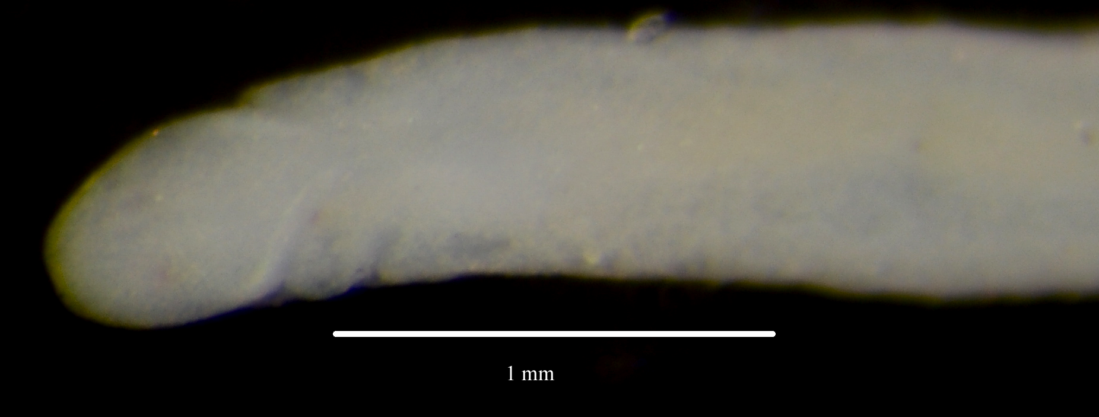

Figure 1. Tetrastemma candidum (uncleared) [note that eyes are barely visible]

