Tetrastemma bilineatum Coe 1904 SCAMIT Vol. , No
Group: Nemertea: Enopla: Hoplonemertea: Tetrastemmatidae

Date Examined: 27 May 2011
Voucher By: Tony Phillips

SYNONYMY: None

LITERATURE:
Bernhardt, P. 1979. A key to the Nemertea from the intertidal zone of the coast of California. (Unpublished).
Coe, W.R. 1904. The Nemerteans. Harriman Alaska Expedition 11:1-220.
Coe, W.R. 1905. Nemerteans of the west and north-west coasts of North America. Bull. Mus. Comp. Zool. Harvard Coll. 47:1-319.
Coe, W.R. 1940. Revision of the nemertean fauna of the Pacific Coast of North, Central and northern South America. Allen Hancock Pacific Exped. 2(13):247-323.
Coe, W.R. 1944. Geographical distribution of the nemerteans of the Pacific coast of North America, with descriptions of two new species. Journal of the Washington Academy of Sciences, 34(1):27-32.
Correa, D.D. 1964. Nemerteans from California and Oregon. Proc. Calif. Acad. Sci., 31(19):515-558.
Crandall, F.B. & J.L. Norenborg. 2001. Checklist of the Nemertean Fauna of the United States. Nemertes (http://nemertes.si.edu). Smithsonian Institution, Washington, D.D. pp. 1-36.

DIAGNOSTIC CHARACTERS:
- Body creamy-white to grayish-yellow, short and broad, not elongate; head region in front of cephalic groove generally not as wide as mid-body; pair of separated dorsal reddish-brown longitudinal bands beginning at the anterior end of the head and running the full length of the body (Figure 1).
- Proboscis sheath extends almost full length of body, proboscis papillated
- Basis approximately equal to 2/3 length of stylet (s/b ratio .91 – 1.5), basis cylindrical shaped, narrower near stylet and base slightly rounded, 1-2 accessory pouches (1 – 2 stylets)
- Eyes not visible uncleared; cleared specimens with single pair of round eyes near anterior edge of head, second pair of round eyes (smaller) just posterior to cephalic furrow. Both sets of eyes on exterior edge of pigmented dorsal longitudinal band.

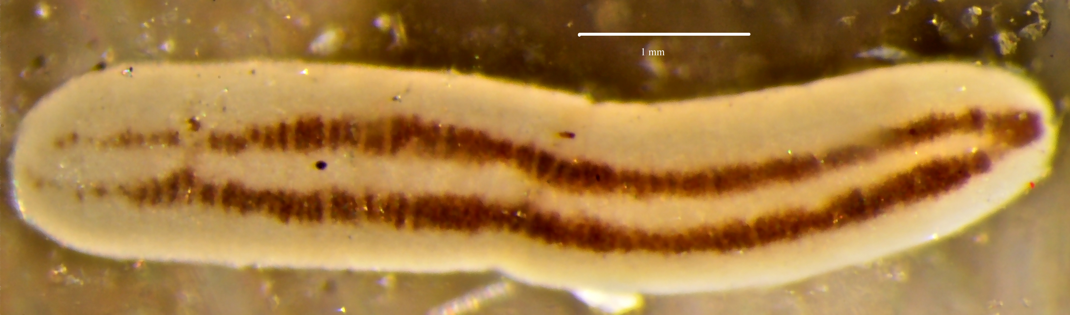
Figure 1. Tetrastemma bilineatum. Avalon (ISS), 4 m, 6 May 2011

RELATED SPECIES AND CHARACTER DIFFERENCES:
The dorsal coloration with the twin reddish-brown longitudinal bands running the entire length of the body are distinctive for this species of Tetrastemma. Tetrastemma quadrilineatum has four reddish-brown to black longitudinal bands running the length of the body. Tetrastemma sexlineatum has six greenish to black longitudinal bands running the length of the body. One variety of Tetrastemma nigrifrons also has two reddish-brown longitudinal bands running the length of the body, but do not start until posterior of the cephalic groove. Also, this form of T. nigrifrons has the distinctive reddish-brown head pigmentation not seen in T. bilineatum. Iwata (1954) actually named this form T. nigrifrons var. bilineatum. Another species reported to be found in this area (Roe et al., 2007) that is similar in appearance is Nemertopsis gracilis Coe, 1904. It is a more elongate nemertean with a pointed anterior end. It also has twin reddish-brown longitudinal bands on the dorsum (Figure 2). The key morphological differences, besides body shape, is that the pair of eyes are reported to be very large and the proboscideal sheath only extends for three-fourths of the body.

DEPTH RANGE: Intertidal – 15 meters

DISTRIBUTION: San Diego to Humboldt Bay

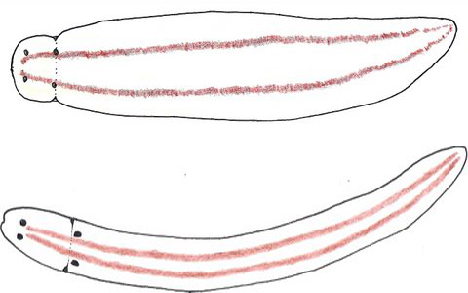

Figure 2. Tetrastemma blineatum and Nemertopsis gracilis (line drawings).

