Tetrastemma albidum Coe 1905 SCAMIT Vol. , No
Group: Nemertea: Enopla: Hoplonemertea: Tetrastemmatidae

Date Examined: 16 May 2007
Voucher By: Tony Phillips

SYNONYMY: Prosorhochmus albidus (Coe 1905)
Monostylifera sp B SCAMIT 1995
Monostylifera sp C SCAMIT 1995

LITERATURE:
Bernhardt, P. 1979. A key to the Nemertea from the intertidal zone of the coast of California. (Unpublished).
Coe, W.R. 1905. Nemerteans of the west and north-west coasts of North America. Bull. Mus. Comp. Zool. Harvard Coll. 47:1-319.
Coe, W.R. 1940. Revision of the nemertean fauna of the Pacific Coast of North, Central and northern South
America. Allen Hancock Pacific Exped. 2(13):247-323.
Coe, W.R. 1944. Geographical distribution of the nemerteans of the Pacific coast of North America, with descriptions of two new species. Journal of the Washington Academy of Sciences, 34(1):27-32.
Correa, D.D. 1964. Nemerteans from California and Oregon. Proc. Calif. Acad. Sci., 31(19):515-558.
Crandall, F.B. & J.L. Norenborg. 2001. Checklist of the Nemertean Fauna of the United States. Nemertes (http://nemertes.si.edu). Smithsonian Institution, Washington, D.D. pp. 1-36.
Maslakova, S.A. et al. 2005. The smile of Amphiporus nelsoni Sanchez, 1973 (Nemertea:Hoplonemertea:Monostilifera:Amphiporidae) leads to a redescription and a change in family.
Proceedings of the Biological Society of Washington, 18(3):483-498.
Maslakova, S.A. & J.L. Norenburg. 2008. Revision of the smiling worms, genus Prosorhochmus Keferstein, 1862, and description of a new species, Prosorhochmus bellzeanus sp. Nov. (Prosorhochmidae, Hoplonemertea) from Florida and Belize. J. Nat. Hist., 42(17):1219-1260.
Roe, P., J.L. Norenburg and S. Maslakova. 2007. Nemertea. In The Light and Smith Manual. Intertidal Invertebrates from Central California to Oregon. Pp. 221-233.

DIAGNOSTIC CHARACTERS:
- Body white, thick, generally of uniform width; posterior portion of head, in front of cephalic groove, with paired reddish-brown pigment patches (Fig. 1).
- Proboscis sheath extends almost full length of body, proboscis papillated.
- Basis even to slightly less than stylet (s/b ratio .57 - .67), basis observed with truncate to cone shape with a slightly rounded base (Figure 2), 1-2 accessory pouches (2 stylets).
- Eyes not visible uncleared, cleared specimens with single pair of eyes near anterior edge of head, a second pair of eyes just posterior to cephalic furrow, both sets of eyes can have elongate projections of pigment emanating outward from eye; speckled brownish-red pigment on the dorsum between both sets of eyes, size and intensity of pigment can vary.

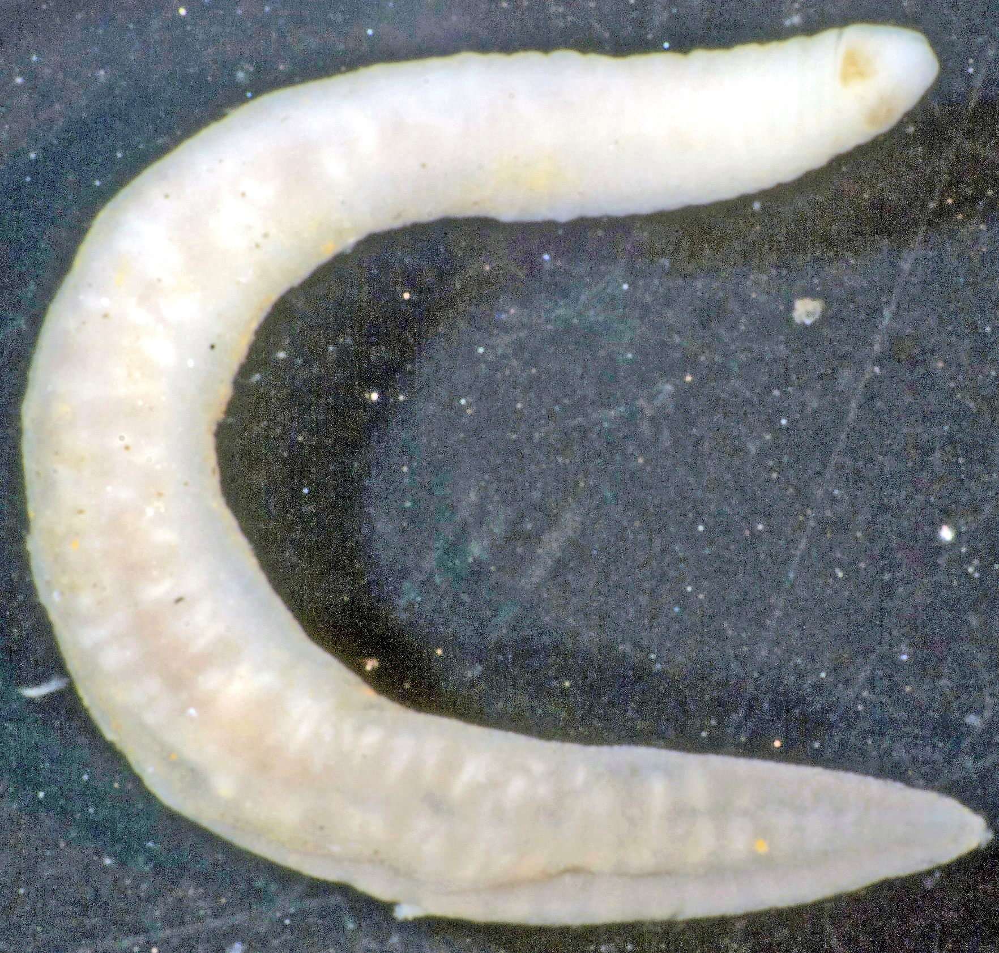
Figure 1. Tetrastemma albidum

RELATED SPECIES AND CHARACTER DIFFERENCES:
This is the only species of Tetrastemma observed that has pigment patches on the head in the southern California Bight. It is also the only species of Tetrastemma that has a truncate basis (Figure 2). At this time Dr. Svetlana Maslakova feels that this species should be left as a Tetrastemma. The primary external morphological character of Prosorhochmus is the prosorhochmid “smile” (see Maslakova & Norenburg, 2008), a horizontal transverse epithelial fold on the head that has not been observed in any of the specimens I examined. They examined specimens collected from southern California in 2002 and found a couple of species that fit Coe’s original description, but is certain neither is a Prosorhochmus due to the above mentioned morphological character and other internal characters. For now they feel that this species is of uncertain taxonomic affinities and best to leave as T. albidum. Until an acceptable revision and diagnosis of the genus Tetrastemma is completed and the proper designation of T. albidum can be ascertained, they feel it is best to re-establish the original designation of Coe.

DEPTH RANGE: 10 - 127 meters

DISTRIBUTION: San Diego to San Francisco

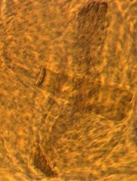
Figure 2. Stylet (14μ) and basis (30μ)

