Oerstedia dorsalis complex SCAMIT Vol. , No
Group: Nemertea: Enopla: Hoplonemertea: Prosorhochmidae

Date Examined: 12 June 2011
Voucher By: Tony Phillips

SYNONYMY: None

LITERATURE:
Bernhardt, P. 1979. A key to the Nemertea from the intertidal zone of the coast of California. (Unpublished).
Coe, W.R. 1905. Nemerteans of the west and north-west coasts of North America. Bull. Mus. Comp. Zool. Harvard Coll. 47:1-319.
Coe, W.R. 1940. Revision of the nemertean fauna of the Pacific Coast of North, Central and northern South America. Allen Hancock Pacific Exped. 2(13):247-323.
Coe, W.R. 1943. Biology of the Nemerteans of the Atlantic coast of North America. Transactions of The Connecticut Academy of Arts and Sciences, 35:129-328.
Coe, W.R. 1944. Geographical distribution of the nemerteans of the Pacific coast of North America, with descriptions of two new species. Journal of the Washington Academy of Sciences, 34(1):27-32.
Coe, W.R. 1951. The Nemertean Faunas of the Gulf of Mexico and of Southern Florida. Bull. Mar. Science of the Gulf and Caribbean, 1(3):149-186.
Correa, D.D. 1961. Nemerteans from Florida and Virgin Islands. Bull. Mar. Science of the Gulf and Caribbean, 11(1):1:44.
Correa, D.D. 1964. Nemerteans from California and Oregon. Proc. Calif. Acad. Sci., 31(19):515-558.
Crandall, F.B. & J.L. Norenborg. 2001. Checklist of the Nemertean Fauna of the United States. Nemertes (http://nemertes.si.edu). Smithsonian Institution, Washington, D.D. pp. 1-36.
Crandall, F.B. et al. 2002, Checklist of the Nemertean Fauna of Japan and Northeastern Asia. Nemertes (http://nemertes.si.edu). Smithsonian Institution, Washington, D.D. pp. 1-44.
Kajihara, H. 2007. A Taxonomic Catalogue of Japanese Nemerteans (Phylum Nemertea). Zoological Science, 24: 287-326.
Roe, P., J.L. Norenburg and S. Maslakova. 2007. Nemertea. In The Light and Smith Manual. Intertidal Invertebrates from Central California to Oregon. Pp. 221-233.

DIAGNOSTIC CHARACTERS:
- Body crème-white, with variable pigment patterns of reddish brown to tan bands, splotches to speckling, thick, generally of uniform width, except for slight narrowing at head and posterior ends.
- Proboscis sheath extends almost full length of body, proboscis papillated.
- Basis approximately equal in length to stylet (s/b ratio 1.0 – 1.13), basis roughly cylindrical, with a rounded base, no accessory pouches observed
- Eyes not visible uncleared; cleared specimens with two pairs of round eyes. The anterior pair in anterior 1/3 of head with the posterior pair, a little more separated and generally even with cephalic groove.

RELATED SPECIES AND CHARACTER DIFFERENCES:
This species has a circumpolar, cosmopolitan distribution. It is an excellent example of what is termed a cryptic specis. The pigment patterns can vary from almost complete coverage to as little as a few speckles. Two species of Tetastemma (nigrifrons and reticulatum) also have a white - creme head region, posterior to this various patterns of solid reddish-brown pigmentation or stripes or blotches are seen. Coe (1951) showed three of the many pigment variations that he had found in the Gulf of Mexico and southern Florida. Recent work with allozymes and DNA bar-coding are beginning to delineate new species from previous groupings of cryptic speciation (Sundberg et al., 2009 and Zaslavskaya and Chernyshev, 2008). Sundberg et al. found for European species that 9 major clades were supported and that different species would prevail through geographic resolution. They found that these species were polymorphic and that no diagnostic features in pigmentation of external characters could separate them within this complex.

DEPTH RANGE: Intertidal to 72 meters

DISTRIBUTION: Puget Sound to Mexico; Japan; both sides of Atlantic; Gulf of Mexico

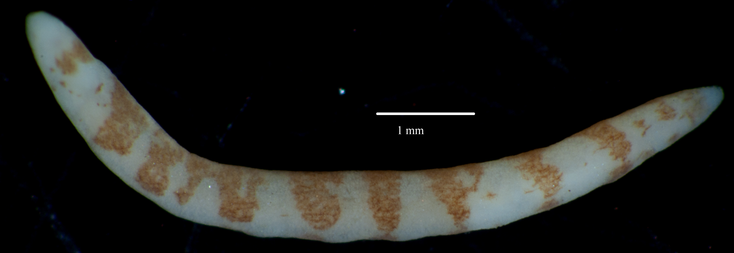
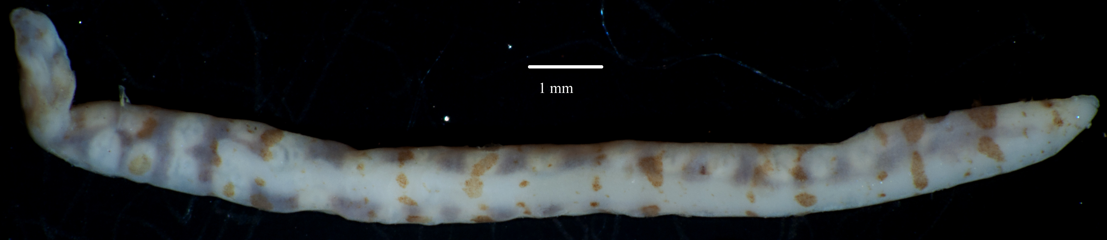
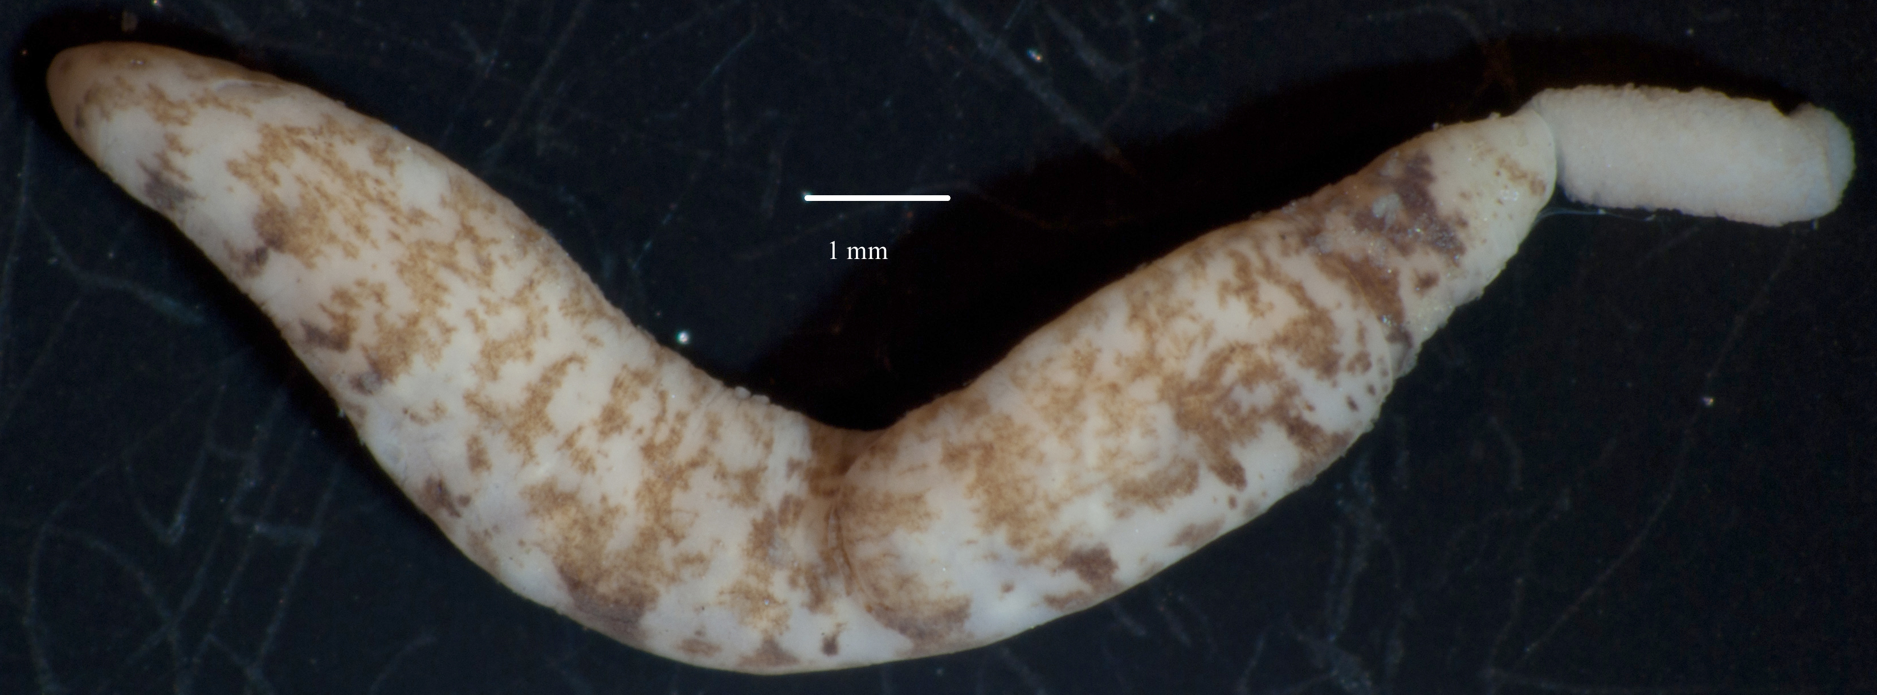
Figure 1. Oerstedia dorsalis complex (uncleared), Long Beach Breakwater, low intertidal rip-rap, 17 July 2007.
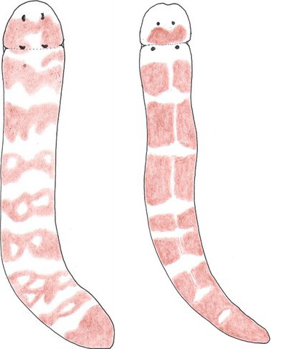

(a) (b)

Figure 2. Comparison of similar pigment patterns seen Oerstedia dorsalis complex (a) and Tetrestemma reticulatum (b)

