Nemertopsis gracilis Coe 1904 SCAMIT Vol. , No
Group: Nemertea: Enopla: Hoplonemertea: Emplectonematidae

Date Examined: 15 July 2011
Voucher By: Tony Phillips

SYNONYMY: None

LITERATURE:
Bernhardt, P. 1979. A key to the Nemertea from the intertidal zone of the coast of California. (Unpublished).
Coe, W.R. 1904. The Nemerteans. Harriman Alaska Expedition 11:1-220.
Coe, W.R. 1905. Nemerteans of the west and north-west coasts of North America. Bull. Mus. Comp. Zool. Harvard Coll. 47:1-319.
Coe, W.R. 1940. Revision of the nemertean fauna of the Pacific Coast of North, Central and northern South America. Allen Hancock Pacific Exped. 2(13):247-323.

DIAGNOSTIC CHARACTERS:
- Body crème-white, elongate (filiform) with pointed anterior, weak cephalic furrow evident; single pair of reddish-brown pigment bands located centrally on the dorsum, connected at both the anterior and posterior end.
- Proboscis sheath short, extends approximately 30 % length of body; proboscideal apparatus discharged in single specimen observed. Coe (1904) reports the basis to be cylindrical without any basal swelling and that the stylet is slender, but indicated from his notes that he did not know if longer or shorter than basis.
- Eyes can be visible uncleared; cleared specimens with two pair of large black eyes (larger than what is observed in Tetrastemma), anterior pair very close together near anterior tip of twin dorsal pigment bands, posterior pair of eyes (slightly larger) wider (outside of twin dorsal pigment bands).

RELATED SPECIES AND CHARACTER DIFFERENCES:
The single pair of reddish-brown pigment bands on the dorsum are very distinctive. Only Tetrastemma bilineatum has this similar pigment pattern. However, T. bilineatum is broad and thick, with a bluntly rounded head and Nemertopsis gracilis is filiform with a pointed head (see Figure 1). T. bilineatum has a grayish-yellow base color and N. gracilis has a crème-white base color.

DEPTH RANGE: Intertidal to 16 meters

DISTRIBUTION: Puget Sound to Ensenada, Mexico

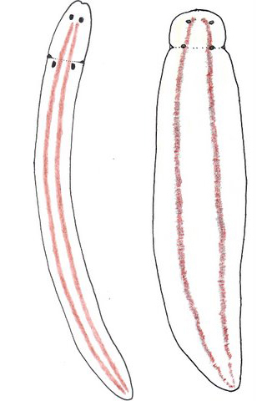

Figure 1. Nemertopsis gracilis Tetrastemma bilineatum

