Cryptonemertes actinophila (Burger 1904) SCAMIT Vol. , No
Group: Nemertea: Enopla: Hoplonemertea: Emplectonematidae

Date Examined: 14 August 2011
Voucher Sheet By: Tony Phillips

SYNONYMY: Monostylifera sp. SD2 of Point Loma

LITERATURE:
Gibson, R. 1986. Redescription and taxonomic reappraisal of Nemertopsis actinophila Burger, 1904 (Nemertea: Hoplonemertea: Monostilifera). Bulletin of Marine Science, 39 (1):42-60.

DIAGNOSTIC CHARACTERS:
- Body white, thin, elongate, generally of uniform width; head with blunt anterior end (the drawing in Gibson, 1986, shows a rounded, slightly wider head).
- Proboscis sheath extends approximately 30% length of body.
- Basis and stylet of approximate equal length (s/b ratio 1.0) (two specimens observed), basis is cylindrical shaped with the base slightly rounded, no accessory sacs observed, but reported to have as many as eight accessory stylets.
- Eyes not visible unless cleared; cleared specimens with two pairs of brick-red eyes; the anterior pair are distinct and found near the tip of the head, the posterior are smaller, more wider set, being found posterior to brain lobes along cerebral ganglia.
- Size of specimens observed: 12 – 45 mm.

RELATED SPECIES AND CHARACTER DIFFERENCES:
This species being so elongate and thin is very distinctive. The two pairs of brick-red eyes, their position in the head and the posterior pair being wider are also distinctive for this species. Though reported as a commensal of actiniarians, all specimens were found in infaunal samples without any actiniarians.

DEPTH RANGE: Intertidal to 150 meters

DISTRIBUTION: San Diego to Goleta
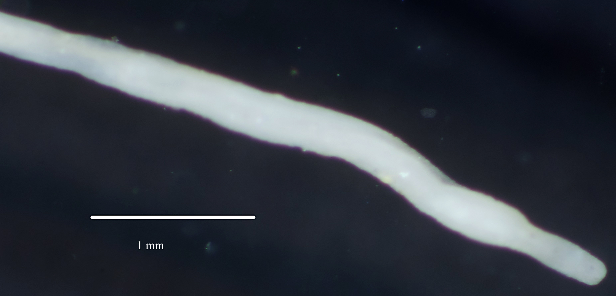
Figure 1. Cryptonemertes actinophila (uncleared) 10 mm. Santa Monica Bay, A2, 16 m, 7 July 2007.

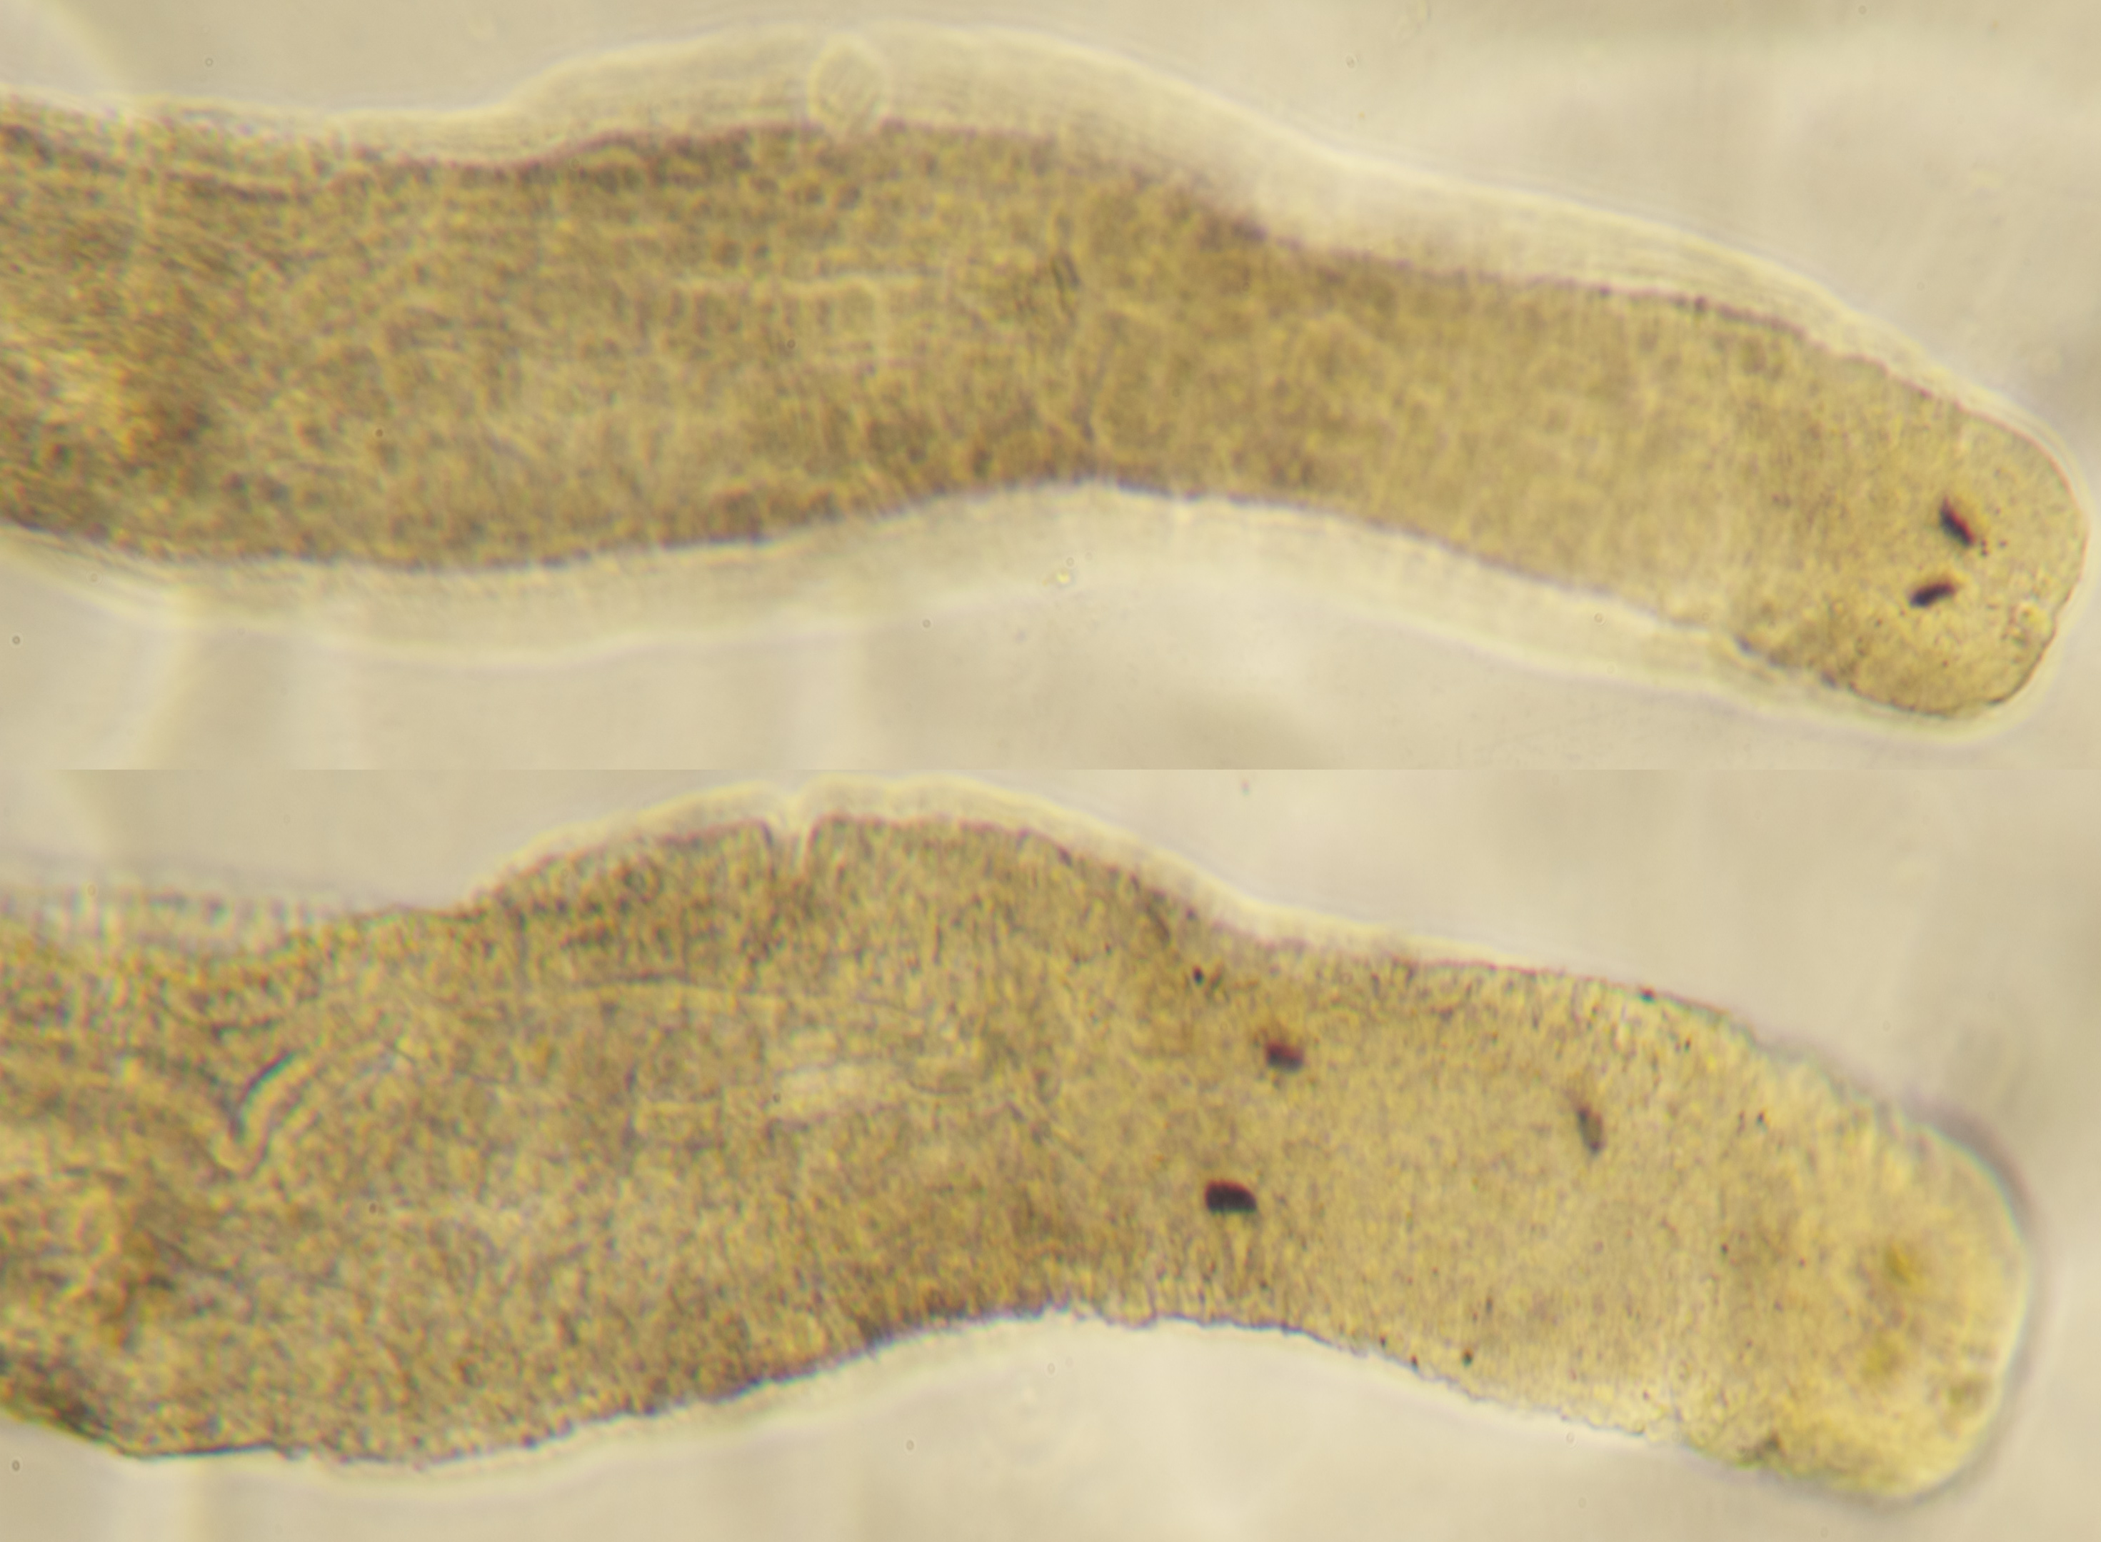

Figure 2. Cryptonemertes actinophila (cleared). Separate pictures of anterior and posterior pair of eyes due to difference in depth within tissue.

