**Amphiporus flavescens** **Coe 1905** SCAMIT Vol. , No

Group: Nemertea: Enopla: Hoplonemertea

Date Examined: 5 January 2011

Voucher By: Tony Phillips

SYNONYMY: Amphiporus sp A Phillips 1988

Amphiporus rubellus (Phillips ID, not Coe 1905)

LITERATURE:

Bernhardt, P. 1979. A key to the Nemertea from the intertidal zone of the coast of California. (Unpublished)..

Coe, W.R. 1905. Nemerteans of the west and north-west coasts of North America. Bull. Mus. Comp. Zool. Harvard Coll. 47:1-319.

Coe, W.R. 1940. Revision of the nemertean fauna of the Pacific Coast of North, Central and northern South America. Allen Hancock Pacific Exped. 2(13):247-323.

Coe, W.R. 1944. Geographical distribution of the nemerteans of the Pacific coast of North America, with descriptions of two new species. Journal of the Washington Academy of Sciences, 34(1):27-32.

Correa, D.D. 1964. Nemerteans from California and Oregon. Proc. Calif. Acad. Sci., 31(19):515-558.

Crandall, F.B. & J.L. Norenborg. 2001. Checklist of the Nemertean Fauna of the United States. Nemertes (<http://nemertes.si.edu>). Smithsonian Institution, Washington, D.D. pp. 1-36.

Crandall, F.B. et al. 2002, Checklist of the Nemertean Fauna of Japan and Northeastern Asia. Nemertes (<http://nemertes.si.edu>). Smithsonian Institution, Washington, D.D. pp. 1-44.

Gibson, R. & F.B Crandall. 1989. The genus Amphiporus Ehrenberg (Nemertea, Enopla, Monostyliferoidea). Zoological Scripta, 18: 453-470.

Roe, P., J.L. Norenburg and S. Maslakova. 2007. Nemertea. In The Light and Smith Manual. Intertidal Invertebrates from Central California to Oregon. Pp. 221-233.

DIAGNOSTIC CHARACTERS:

1. Body yellowish-white to crème white.
2. Proboscis sheath extends almost full length of body, proboscis papillated
3. Basis approximately equal in length to stylet (s/b ratio 0.79 – 1.38), basis has a thin pear to cylindrical shape with the base rounded; 1-2 accessory pouches with 1-2 accessory stylets.

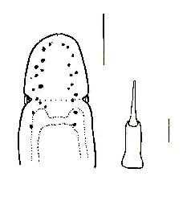

1. eyes not visible unless cleared; cleared specimens with three groups of eyes on each side of head. A single row of 4-8 round eyes is found along the anterior-lateral edge of head, followed by a cluster of 4-8 eyes just inside of end of first cluster to edge of cephalic furrow, with a single row of 3-10 eyes trailing posteriorly over brain lobes and along brain stem that start posterior and outside of anterior-lateral row. This species shows a great variability in eye pattern in relation to body size.
2. Size of specimens observed 1 – 23 mm.

RELATED SPECIES AND CHARACTER DIFFERENCES:

Unless cleared there are many species of Amphiporus, Tetrastemma and provisional species of Hoplonemertea that have a similar appearance. Amphiporus californicus has a somewhat similar eye pattern to A. flavescens. The two rows of eyes in A. californicus have 4-8 pairs in an irregular linear line, while A. flavescens can have 6 – 13 pairs of eyes in three separate groupings. Earlier identifications by this author of A. rubellus Coe 1905 were actually A. flavescens (pages in Coe 1905, 239/241, stuck together which made first page of A. rubellus description run-on with first page of A. flavescens description. This error was seen when reading a second copy of Coe 1905.

DEPTH RANGE: 5-128 meters

DISTRIBUTION: Monterey, Ca. to Ensenada, Mexico

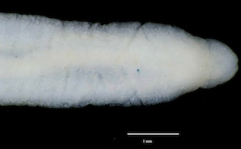

Figure 1. Amphiporus flavescens (uncleared) 12 mm. Goleta, B4(5), 30 m, 7 October 2008.