**Amphiporus cruentatus (Hubrecht, 1879)** SCAMIT Vol. , No

Group: Nemertea: Enopla: Hoplonemertea

Date Examined: 12 June 2011

Voucher Sheet By: Tony Phillips

SYNONYMY: None

LITERATURE:

Bernhardt, P. 1979. A key to the Nemertea from the intertidal zone of the coast of California. (Unpublished)

Coe, W.R. 1905. Nemerteans of the west and northwest coasts of America. Bull. Museum Comparative Zool. Harvard. 47: 1-319, pl. 1-25.

Coe, W.R. 1940. Revision of the nemertean fauna of the Pacific coasts of North, Central and northern South America. Allan Hancock Pacific Expeditions. 2: 247-323.

Coe, W.R. 1944. Geographical distribution of the nemerteans of the Pacific coast of North America, with descriptions of two new species. Jour of the Washington Academy of Sciences, 34:27-32.

Correa, D.D. 1964. Nemerteans from California and Oregon. Proc. Calif. Acad. Sci. 31 (19):515-558.

Crandall, F.B. & J.L. Norenborg. 2001. Checklist of the Nemertean Fauna of the United States. Nemertes (<http://nemertes.si.edu>). Smithsonian Institution, Washington, D.D. pp. 1-36.

Gibson, R. & F.B Crandall. 1989. The genus Amphiporus Ehrenberg (Nemertea, Enopla, Monostyliferoidea). Zoological Scripta, 18: 453-470.

Roe, P., J.L. Norenburg and S. Maslakova. 2007. Nemertea. In The Light and Smith Manual. Intertidal Invertebrates from Central California to Oregon. Pp. 221-233.

DIAGNOSTIC CHARACTERS:

1. Body white, thin, generally of uniform width; longest species of Amphiporus observed in SCB.
2. Proboscis sheath extends almost full length of body, proboscis papillated.
3. Basis approximately 2X length of stylet (s/b ratio 0.45 – 0.70), basis an elongated cylinder of uniform width, base rounded; 1-2 accessory sacs (usually absent) with 1-3 accessory stylets.

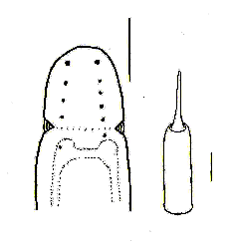

1. Eyes not visible unless cleared. Sometimes cerebral blood vessal visible entwined among both rows of eyes (Figure 1); cleared specimens with 5-10 pairs of eyes in two uniform rows from anterior of head to just past cerebral groove, anterior pair largest, grading smaller to the posterior.
2. Size of specimens observed: 7 – 22 mm.

RELATED SPECIES AND CHARACTER DIFFERENCES:

Unless cleared there are a many species of Amphiporus, Tetrastemma and provisional species of Hoplonemertea that have a similar appearance. Upon being cleared there is only one species of Amphiporus that could be confused with A. cruentatus, this being A. californicus. The most similar character is the single row of 4-8 pair of eyes in an irregular row from anterior of head to just past cerebral groove, usually the anterior pair is the largest. This eye row is very irregular compared to the linear form of the eyes seen in A. cruentatus. The shape of the basis is distinctly different being pear shaped compared to the elongate cylinder in A. cruentatus. The s/b ratio of A. californicus is .94 – 1.12, while in A. cruentatus it is 0.45 – 0.70. Lastly, A. californicus does not have the cerebral blood vessal in the head region entwined around the rows of eyes.

DEPTH RANGE: 15 – 75 meters

DISTRIBUTION: Puget Sound to San Diego

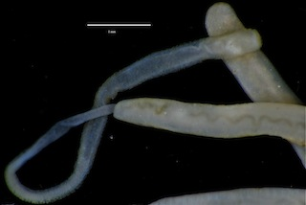

Figure 1. Amphiporus cruentatus (uncleared) 17 mm. Goleta B6(1), 30 m, 7 October 2008.

* cerebral blood vessal visible as light brown squiggly line