**Amphiporus californicus Coe 1905** SCAMIT Vol. , No

Group: Nemertea: Enopla: Hoplonemertea: Amphiporidae

Date Examined: 12 June 2011

Voucher Sheet By: Tony Phillips

SYNONYMY: None

LITERATURE:

Bernhardt, P. 1979. A key to the Nemertea from the intertidal zone of the coast of California (Unpublished).

Coe, W.R. 1905. Nemerteans of the west and northwest coast of America. Bull. Museum Comparative Zool. Harvard, 47: 1-319, pl. 1-25.

Coe, W.R. 1940. Revision of the nemertean fauna of the Pacific Coast of North, Central and northern South America. Allan Hancock Pacific Exped. 2: 247-323.

Coe, W.R. 1944. Geographical distribution of the nemerteans of the Pacific coast of North America, with descriptions of two new species. Journal of the Washington Academy of Sciences, 34: 27-32.

Correa, D.D. 1964. Nemerteans fro California and Oregon. Proceedings of the California Academy of Sciences, 31:515-558.

Crandall, F.B. & J.L. Norenborg. 2001. Checklist of the Nemertean Fauna of the United States. Nemertes (<http://nemertes.si.edu>). Smithsonian Institution, Washington, D.D. pp. 1-36.

Gibson, R. & F.B Crandall. 1989. The genus Amphiporus Ehrenberg (Nemertea, Enopla, Monostyliferoidea). Zoological Scripta, 18: 453-470.

DIAGNOSTIC CHARACTERS:

1. Body white, thick, generally of uniform width.
2. Proboscis sheath extends almost full length of body, proboscis papillated
3. Basis and stylet of approximate equal length (s/b ratio 0.94 – 1.12), basis has a broad pear shape with the base slightly rounded; 1-2 accessory sacs with 1-2 accessory stylets.

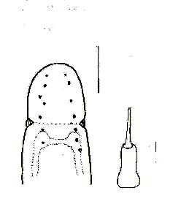

1. Eyes not visible unless cleared; cleared specimens with 4–8 pairs of eyes in irregular row from anterior of head to just past cerebral groove, usually the anterior pair of eyes generally largest.
2. Size of specimens observed: 3 – 5 mm.

RELATED SPECIES AND CHARACTER DIFFERENCES:

Unless cleared there are a many species of Amphiporus, Tetrastemma and provisional species of Hoplonemertea that have a similar appearance. Upon being cleared there is only one species of Amphiporus with a similar eye pattern that could be confused with A. californicus, this being A. cruentatus. There is a single row of 5–10 pairs of eyes in a regular row from anterior of head to just past cerebral groove, with the anterior pair being the largest (see A. cruentatus sheet). There are two distinct characters that will help you differentiate the two species. If the proboscideal apparatus is present the shape and s/b ratio are different. In A. cruentatus the basis is cylindrical of uniform width and the s/b ratio is 0.46 – 0.71. The cerebral blood vessal in A. cruentatus is readily visible even when not cleared as a distinct red line. It forms a rectangular shape beginning from the one brain stem to the anterior of the head and back to the other brain stem before reconnecting with lateral blood vessal (Text fig. 20, Coe 1905)

DEPTH RANGE: 3 – 75 meters

DISTRIBUTION: San Diego to Goleta

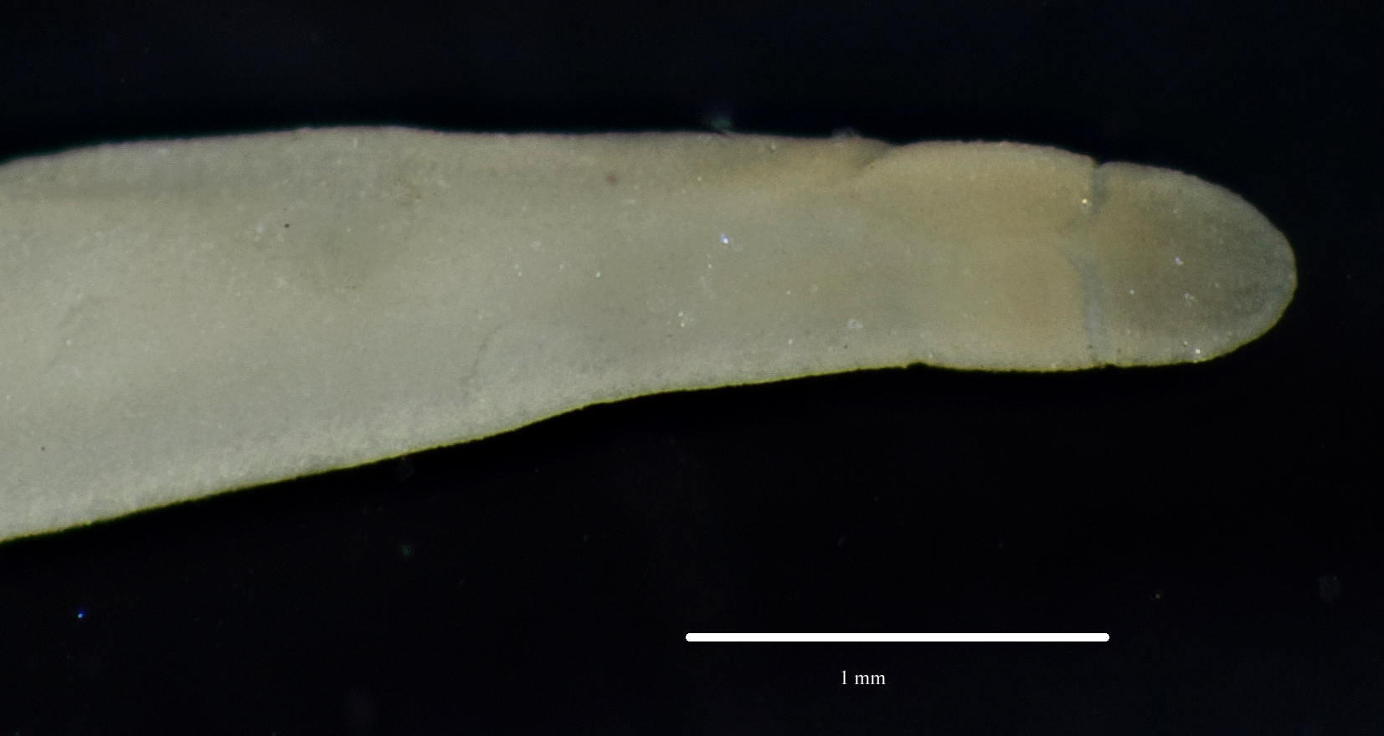

Figure 1. Amphiporus californicus, uncleared specimen. Goleta, B2, 30 m, October 2008.